
GEO WEEK 2022
31 October – 4 November 2022
ACCRA INTERNATIONAL CONFERENCE CENTER, GHANA

EXHIBITION SERVICES GUIDE
AND BOOTH REQUEST FORM

Sample booths

We will brand exhibition booths in advance of your arrival for the exhibition set-up.

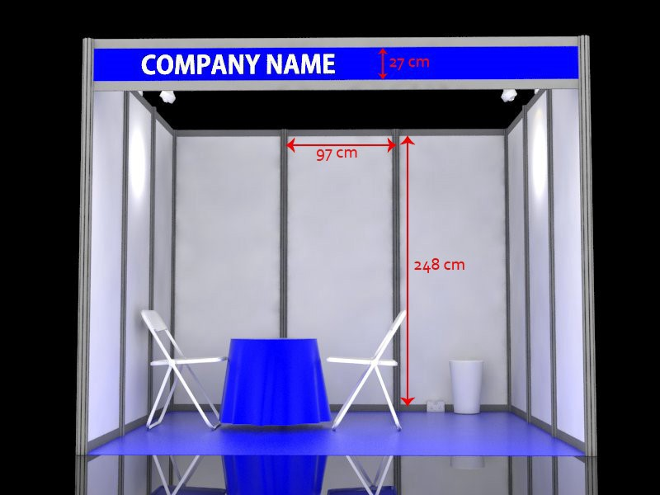
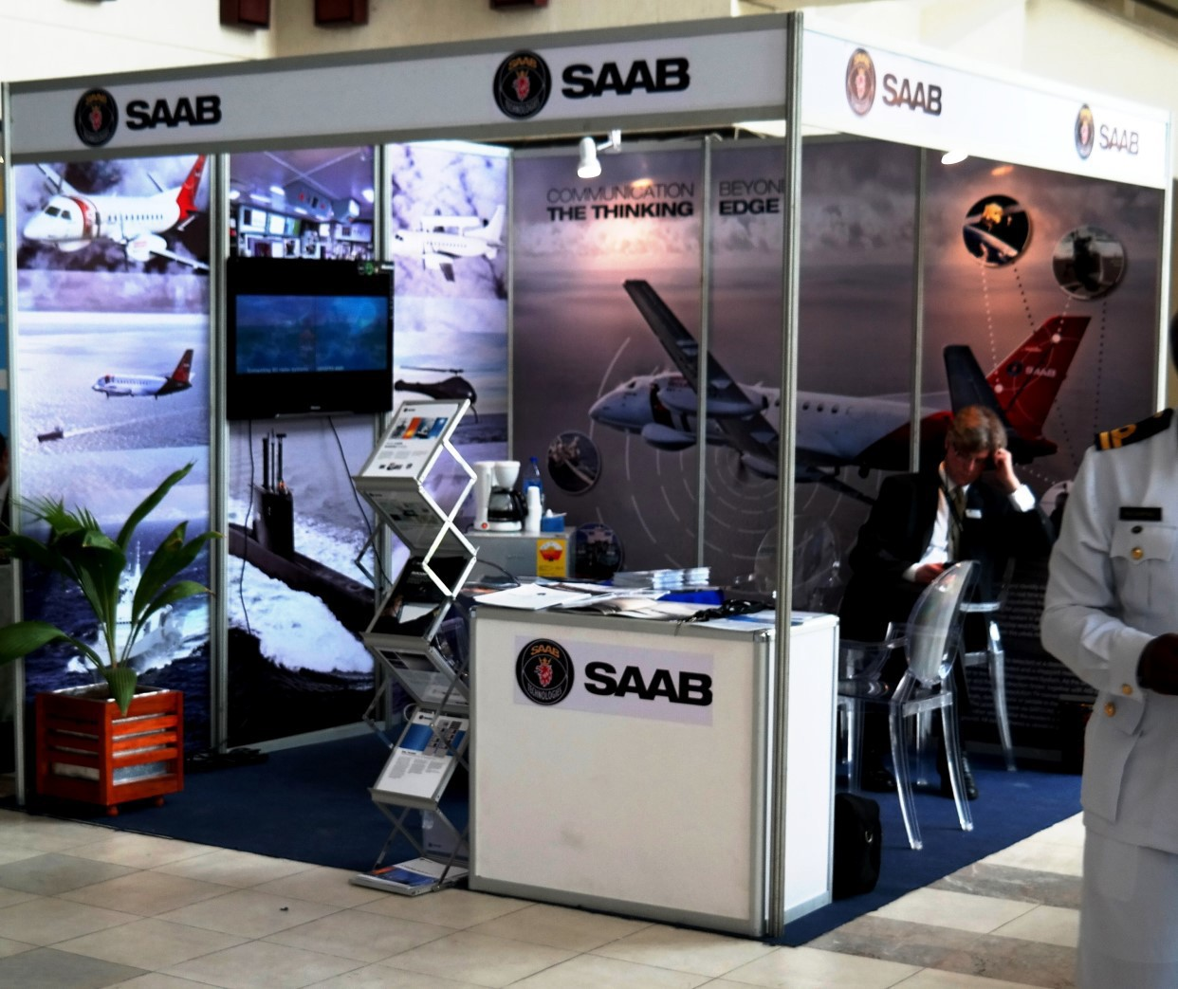

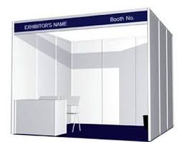
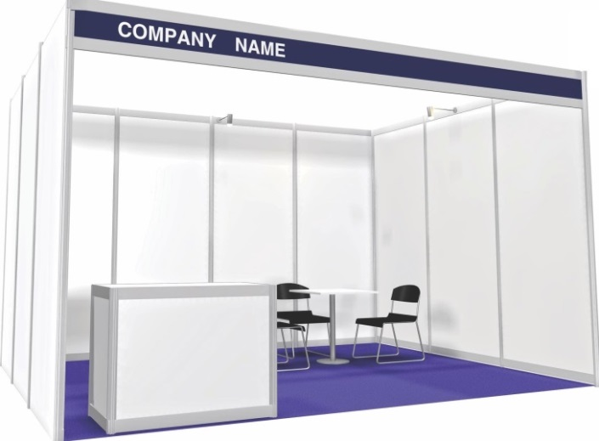

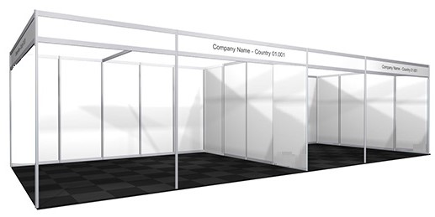

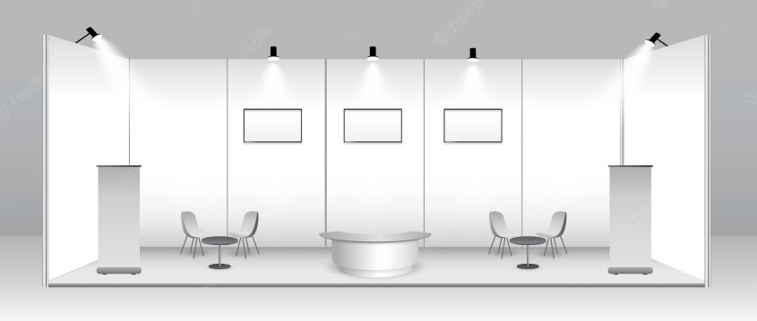

Prices

 | Description | Unit Cost USD  per day
1 | Standard booth: 9 square meters (3 shell scheme)  - table  - 2 chairs  - 2 spot lights  - carpet  - rubbish bin  - 2 power sockets  - fascia name including logo | 675
2 | Printing and installing graphics on booth panels. (97cm x 248cm) | 80 (one off cost)
3 | Customized booths according to company’s designs and specifications | To be discussed with the event secretariat
4 | Additional items. | Refer to cost table below

Note:
Multiple booths may be requested to create a larger space. If exhibitors require a slightly larger booth, the cost per square metre is 75 USD per day. Please contact the organizers to discuss your requirements.

Standard measurements for booth panels are 248cm (H) x 97cm (W). Fascia’s have a printable area of 27 cm from top to bottom.

Send high resolution versions of your print-ready artwork to geoweek22exhibition@gmail.com via your preferred ftp site, Dropbox, or Google share drive.

ADDITIONAL ITEMS:

FURNITURE & ACCESSORIES

001 counter unit  $80 | 002 set of 3 shelves  $55 | 003 folding table with cloth $20 | 004 folding chair  $30 | 005 tub chair  $80
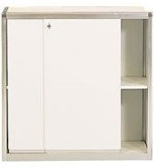 | 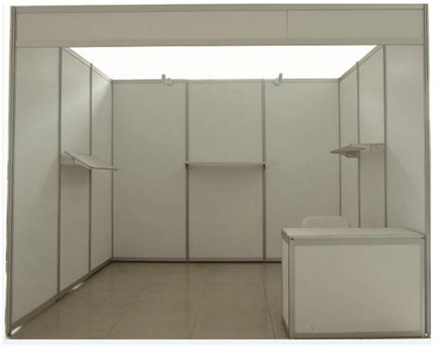 | 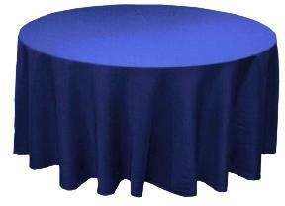 | 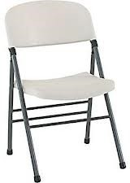 | 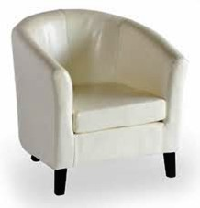
006 glass topped meeting table/chairs  $180 | 007 pedestal bar stool black/white $40  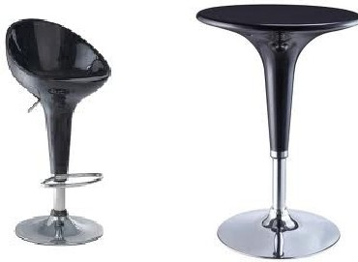 | 008 pedestal bar table $45 | 009 fridge 50cms x 50cms x 85cms  $70 | 010 coffee maker  $60
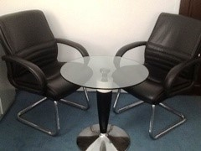 |  |  | 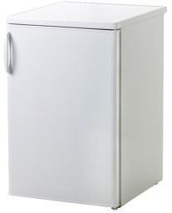 | 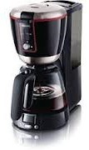
011 32” LCD monitor with HDMI cable floorstand  $150 | 012 42” – 55” LCD with VGA /HDMI cable floorstand $180, $250 | 013 Optima/  Acer projector Ansi Lumens $150 | 014 screen 180cms x 180cms  $55 | 015 additional 13A plug point  $35
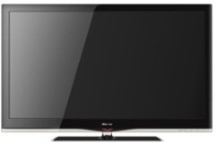 | 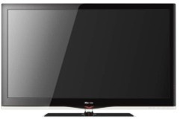 | 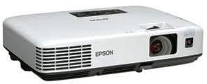 | 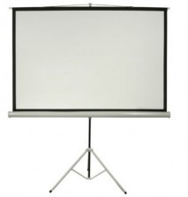 | 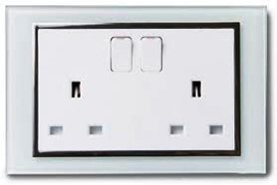
016 40” adjustable aim spotlight $42 | 017 1.2m single fluorescent light fitting $40 | 018 single phase consumer unit  $130 | 019 standing pedestal fan $45 | 020 continental trailer socket $30
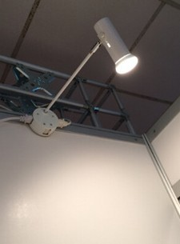 | 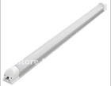 | 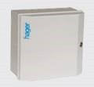 | 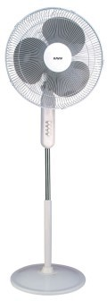 | 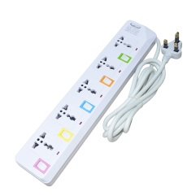
URN
FURNITURE & ACCESSORIES CONT’D

021 lockable door for storeroom 100cm x 250cm $115 | 022 additional shell scheme panels 100cmx 250cm $25 | 023 acrylic panel 100cm x 250cm  $45 | 024 lockable glass showcase 50cm x 50cmx 100cm $150 | 025 lockable glass showcase 100cm x 50cmx 100cm $170
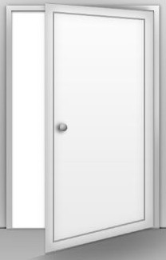 | 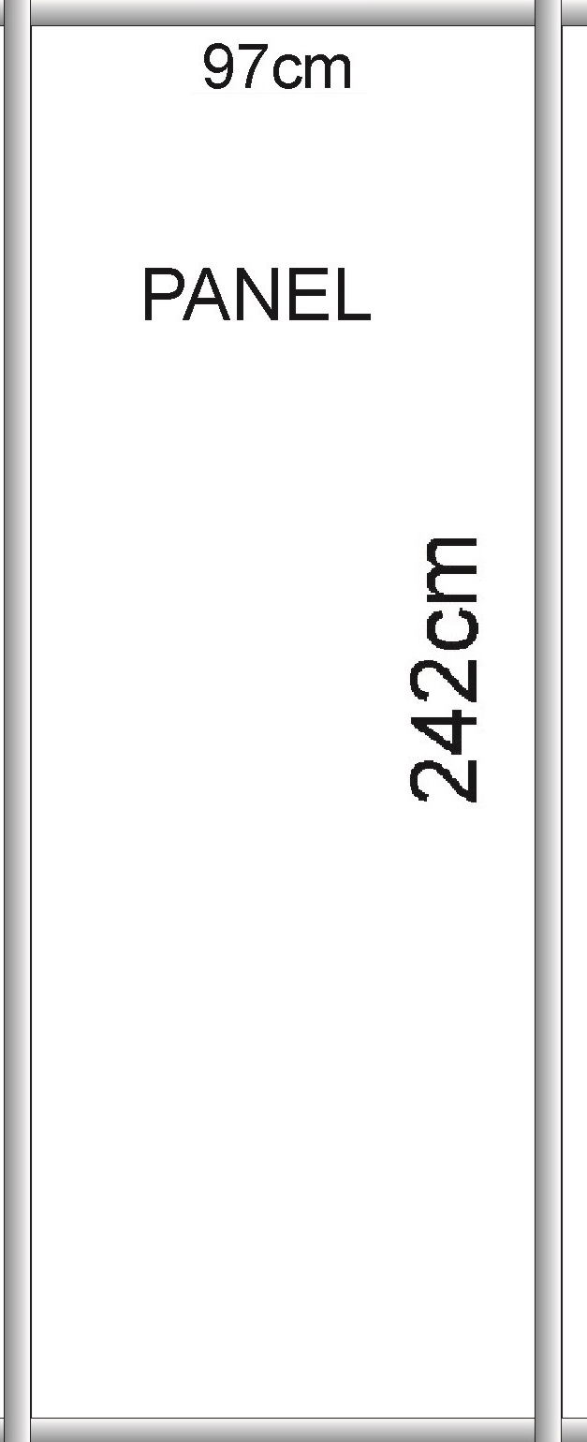 |  | 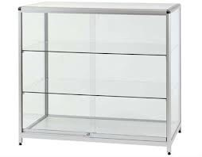
026 podium 50cms x | 027 multi-tiered | 028 coat hooks for | 029 DVD player for | 030 graphic print /
50cms x 100cms  $45 | literature rack $40 | use inside closet $20 | LCD’s 011/012  $45 | install 1 shell scheme 97cm x  248cm $80
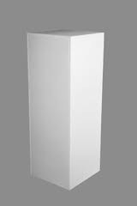 | 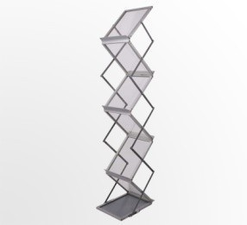 | 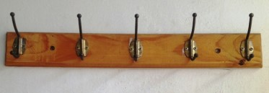 | 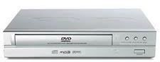 | 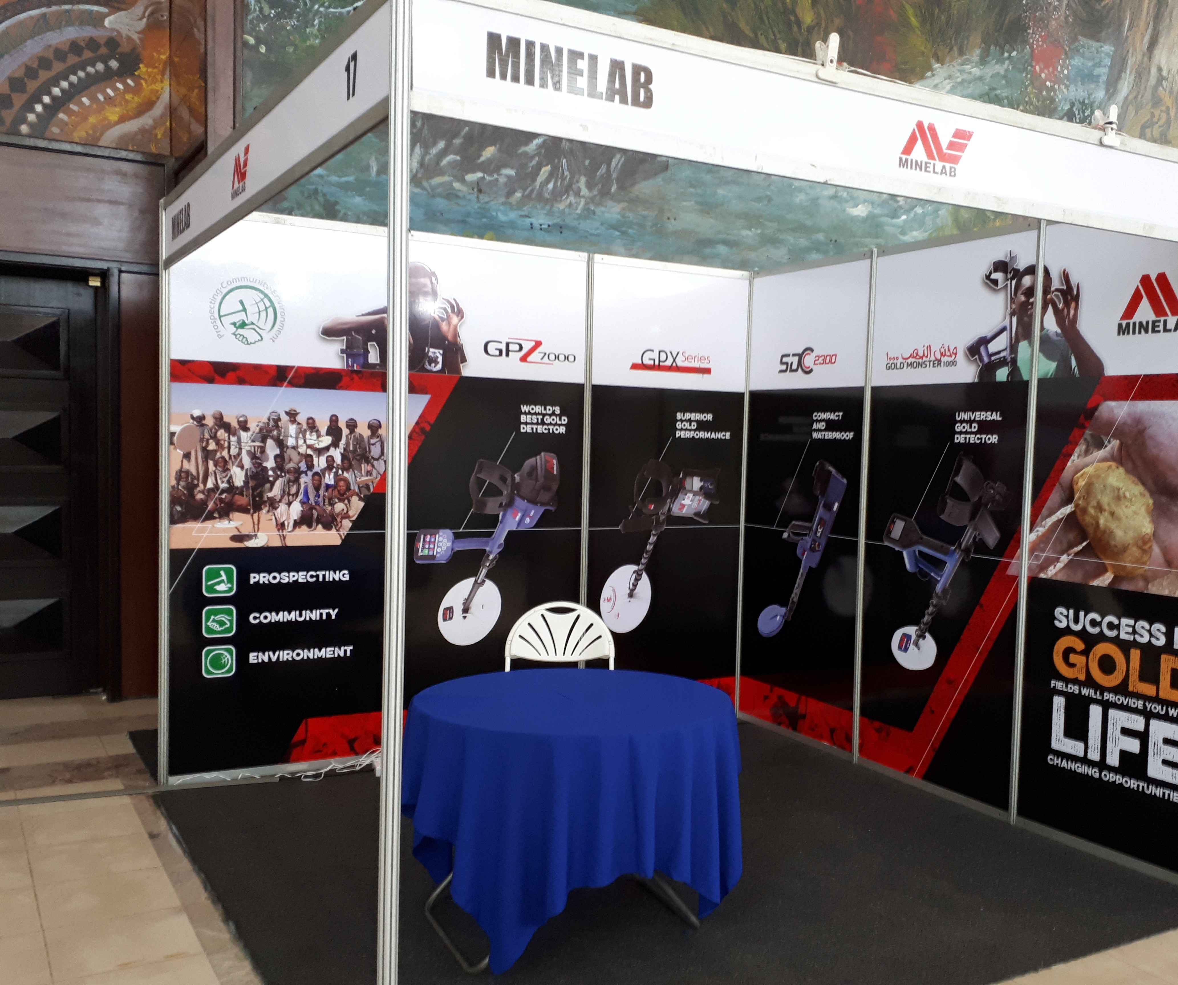
031 pull-up banner—  print/install $295 | 032 flower basket with green plants $49 | 034 queue control barriers $35
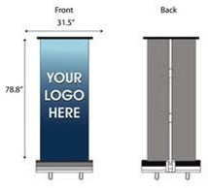 | 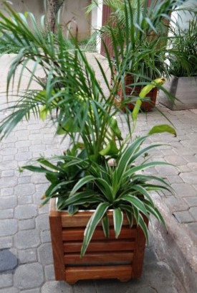 | 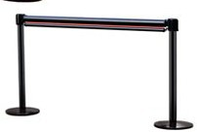

BOOTH REQUEST FORM  (Compulsory for standard shell scheme stand exhibitors) | Return this form to:  The Event Secretariat  Email: geoweek22exhibition@gmail.com

Company name
Company Address
Country / City
Telephone no.
Email address
Contact person
Number of booths requested
Additional space (square meters)
Additional Electricity Requirements

Furniture and accessories requested
no | Item |  | Qty | Unit cost  USD per day | No. of days | Total cost USD
1 | Counter unit with shelf and lockable door |  |  | 80
2 | Shelf - set of 3 (1m wide) |  |  | 55
3 | Folding table with cloth |  |  | 20
4 | Chair |  |  | 30
5 | Tub chair (simulated white leather) |  |  | 80
6 | Meeting table/chairs (2) |  |  | 180
7 | Bar stools |  |  | 40
8 | Bar tables |  |  | 45
9 | Fridge 500mm (L) x 500mm (W) x 850mm (H) |  |  | 70
10 | Filter coffee maker with |  |  | 60
11 | 32” LCD HD monitor with VGA/HDMI cable |  |  | 150
11A | LCD monitor stand for above |  |  | 40
12 | 42” LCD monitor with VGA/HDMI cable |  |  | 170
12A | LCD monitor stand for above |  |  | 40
12B | 50” LCD monitor with VGA cable |  |  | 220
12C | LCD monitor stand for above |  |  | 40
12D | LCD wall mounting installation |  |  | 40
13 | Optima/Acer projector Ansi Lumens |  |  | 150
14 | Projector screen 180cms x 180cms |  |  | 55
15 | 13amp plug point |  |  | 35
16 | 150 watt spotlight |  |  | 42
17 | Fluorescent fitting 1.2m |  |  | 40
18 | Consumer unit single phase |  |  | 130
19 | Standing fan |  |  | 45
20 | Continental trailer socket |  |  | 30
21 | Lockable door for storeroom 1m x 2.5m |  |  | 115
22 | Additional shell scheme panels 1m x 2.5m |  |  | 25
24 | Lockable glass showcase 50 x 100 x 50 |  |  | 150
25 | Lockable glass showcase 100 x 50 x 100 |  |  | 170
26 | Podium 500mm (L) x 500mm (W) x 1000mm (H) |  |  | 45
27 | A4 literature dispenser – multitiered |  |  | 40
28 | Coat hooks |  |  | 20
29 | DVD player |  |  | 30
30 | Print and install display graphics 2.48m x 0.97m |  |  | 80
31 | Pull-up banner - supply, print and install |  |  | 295
32 | Flower basket with assorted green plants |  |  | 49
33 | Coffee maker machine |  |  | 70
34 | Queue control barrier - per pair |  |  | 35
TOTAL (USD)

Following receipt of your booth request, a quotation invoice will be sent to you via email
for approval prior to allocation of your booth and payment.

Customer signature………………………………………………. Date…………………………

